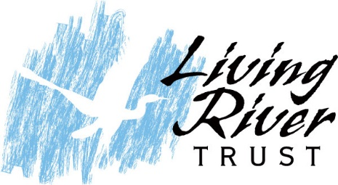

Press Release
Feb 16, 2022
Contact Liz Friel, Executive Director
lizfriel@livingrivertrust.org
5712059141
www.livingrivertrust.org

A conservation non-profit just struck an innovative deal to conserve nearly 90 acres of pristine waterfront land for the public to enjoy in the City of Chesapeake. The Living River Trust (LRT) works to conserve the “last 10%” of undeveloped land in the environmentally sensitive Elizabeth River Watershed. This now-protected land is referred to as “Newton Neck” is nestled along the Southern Branch of the Elizabeth River in Chesapeake, among established neighborhoods, a marina, and industrial uses.

“This land is special; it has never been developed and in its natural state with wetlands, mature woodlands, and a gorgeous waterfront. Conservation is the ultimate protector of the environment and water quality, especially in these largely developed areas” says Liz Friel, the Executive Director of the Living River Trust.

A unique partnership and foresight made not only the conservation of the land possible, but also the dedication of the land to public use for Chesapeake in the form of passive recreation such as trails. The protection of the land began with LRT reaching out to the longtime owners of the property, the Vann family (Southport Land Corporation) in 2020. The Vanns agreed to consider the sale of the property to the Living River Trust with the requirement that their family’s property be dedicated as permanent open space for public use by the City of Chesapeake. LRT’s mission was then to facilitate the conservation and public use of the land and to secure funding.

After Chesapeake’s Mayor West, City Council and several of Chesapeake’s legislative delegation toured the property; they immediately recognized its pristine condition, outstanding ecological significance, and open space value as a park. A General Assembly appropriation secured the property’s selling price and was funded through the Virginia Department of Conservation and Recreation (DCR). The advocates for the funding were numerous with Delegate C.E. “Cliff” Hayes submitting the budget amendment, strategic counsel of Delegate Barry Knight in addition to the support of Chesapeake’s entire legislative delegation.

Additionally, the Living River Trust secured an Open Space Lands Preservation Trust Fund Public Access grant from the Virginia Outdoors Foundation to cover technical assistance costs to allow the property to be sold and dedicated to public use.

A year of work and research by all partners came to fruition earlier this month as the City of Chesapeake formalized its acceptance of the property. As the Chair of the Living River Trust, Mary Ann Saunders, put it; “This is a huge win for conservation and the community”. LRT is grateful to have led and facilitated the partnership and plans to use this model elsewhere to protect these rare and environmentally important lands in the region.

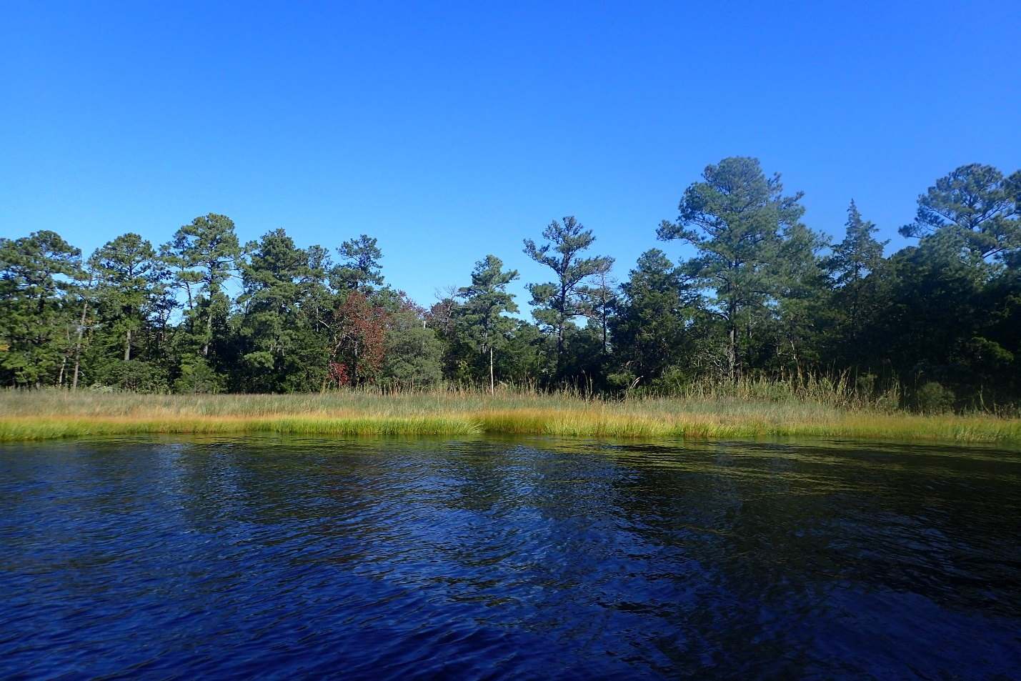

Newton Neck from the Southern Branch of the Elizabeth River. Photo by Mary Bennett.

